Convert users_id to user_id in staff table.
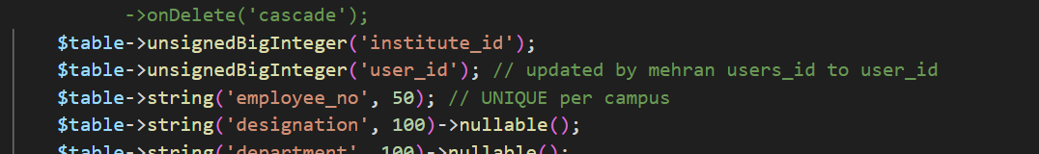

User is missing in student table.

